

《软件工程原理与应用》
系统设计报告
电脑硬件分析推荐系统
小 组 | 101 B 胡天齐 吴奕衡 谷陶陶
学院 | 计算机科学与技术学院/软件学院
专业 | 计算机科学与技术
班级 | 1623101

二〇二五年十一月
目 录
一、引言 3
1、编写目的 3
2、背景 3
3、定义 3
4、参考文献 4
二、界面设计 5
1、OrdinaryUser类 5
2、Administrator类 8
3、Hardware_Inf类 12
4、Evaluation类 15
5、Collect类 17
6、Comment类 19
三、事务逻辑设计 20
1、OrdinaryUser类 20
2、 Administrator类 24
3、 Hardware_Inf类 30
4、Evaluation类 31
5、Collect类 33
6、Comment类 34
四、数据库设计 36
1、 User类 36
2、 OrdinaryUser类 36
3、 Administrator类 36
4、 Hardware_Inf类（子类8选3） 37
5、 Evaluation类 38
6、 Collect类 38
7、 Comment类 38
8、 Media_Inf类 38

一、引言

1、编写目的
需求说明书目的是使用户和软件开发者双方对该软件有一个共同的理解，使之成为整个开发工作的基础。便于用户、开发人员进行理解和交流，反映出用户问题的结构，可以作为软件开发工作的基础和依据，并作为确认测试和验收的依据。
预期读者：软件设计者和测试者。

2、背景
说明：
- 待开发的软件系统的名称：电脑硬件分析推荐系统
- 本项目的任务提出者：胡天齐 吴奕衡 谷陶陶；
- 本项目的任务开发者：胡天齐 吴奕衡 谷陶陶；
- 用户：有电脑硬件选购需求的个人用户（如游戏玩家、内容创作者、办公用户等）、电脑组装门店及相关硬件销售商家；
- 实现该软件的计算中心或计算机网络：南京航空航天大学计算中心。

3、定义
名称 | 说明
账号 | 用户注册时登记的用户名（手机或邮箱）及密码
用户分类 | 用户、管理员
账户信息管理 | 用户与管理员都可通过该模块对自己的信息进行增加、查询、修改、删除操作，分别对应注册、登录、修改用户信息及找回密码、注销，管理员拥有对所有用户的信息进行各项操作的权限
发布硬件信息 | 管理员填写硬件参数、价格、库存等信息表单后送审，审核通过后在系统展示
修改硬件信息 | 发布硬件信息的管理员修改硬件参数、价格、库存等信息后送审，审核通过后更新系统展示内容
查看硬件信息 | 所有用户均可查看已发布的硬件信息，并通过硬件型号、类别、品牌等关键词查询特定硬件信息，且支持多条件检索和获取推荐列表
审核硬件信息 | 管理员审核发布或修改的硬件信息，可以选择通过或退回
下架硬件信息 | 管理员可下架过时的硬件信息，审核通过后该硬件信息不再在系统展示
收藏硬件信息 | 用户可以收藏感兴趣的硬件产品信息
取消收藏硬件信息 | 用户可以取消已收藏的硬件产品信息
查看收藏硬件信息 | 用户可以查看收藏的硬件信息
发布硬件测评 | 用户或管理员可发布硬件使用测评，包含性能测试数据、使用体验、优缺点分析等内容
查看硬件测评 | 用户和管理员可以查看已通过审核的硬件测评
审核硬件测评 | 管理员审核用户发布的硬件测评，可以选择通过或退回
删除硬件测评 | 发布该测评的用户或管理员可以删除硬件测评
发表测评评论 | 用户可以在硬件测评下发表评论，交流使用心得或提问
查看测评评论 | 用户查看其他人或自己发布过的测评评论
审核测评评论 | 管理员审核用户发表的测评评论，可以选择通过或退回
删除测评评论 | 发布该评论的用户或管理员可以删除测评评论

4、参考文献
- Ricci F, Rokach L, Shapira B. Recommender Systems Handbook[M]. 3rd ed. Springer US, 2022.
[2] PCPartPicker. About PCPartPicker[EB/OL]. https://pcpartpicker.com/about/.
[3] 刘建国, 周涛, 汪秉宏. 个性化推荐系统的研究进展[J]. 自然科学进展, 2009, 19(1): 1-15.
[4] Zhang S, Yao L, Sun A, et al. Deep Learning based Recommender System: A Survey and New Perspectives[J]. ACM Computing Surveys (CSUR), 2019, 52(1): 1-38.
[5]齐治昌，谭庆平，宁洪：《软件工程》（第四版）

二、界面设计

1、OrdinaryUser类
signupOrdinaryUser.html | 普通用户注册页面
web：
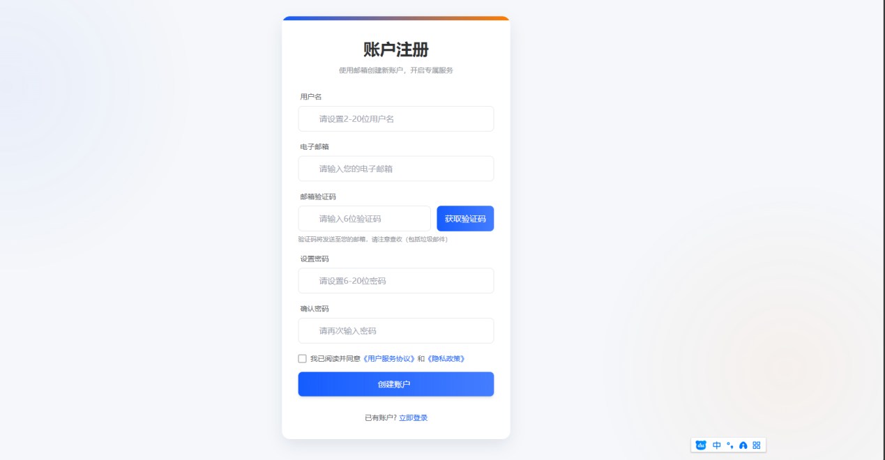
app:
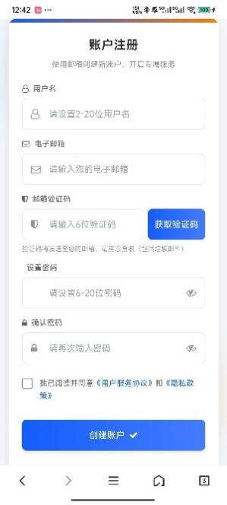

signin.html | 登录页面
web:
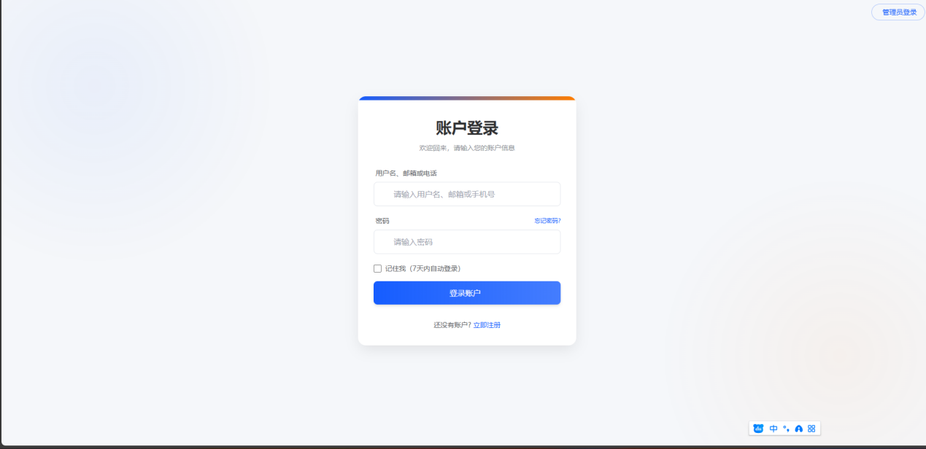
app:
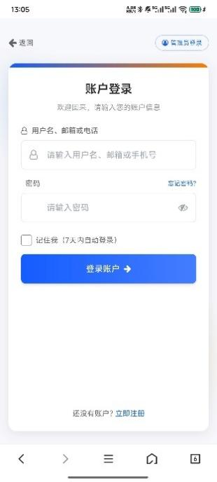

index1.html | 首页
web: 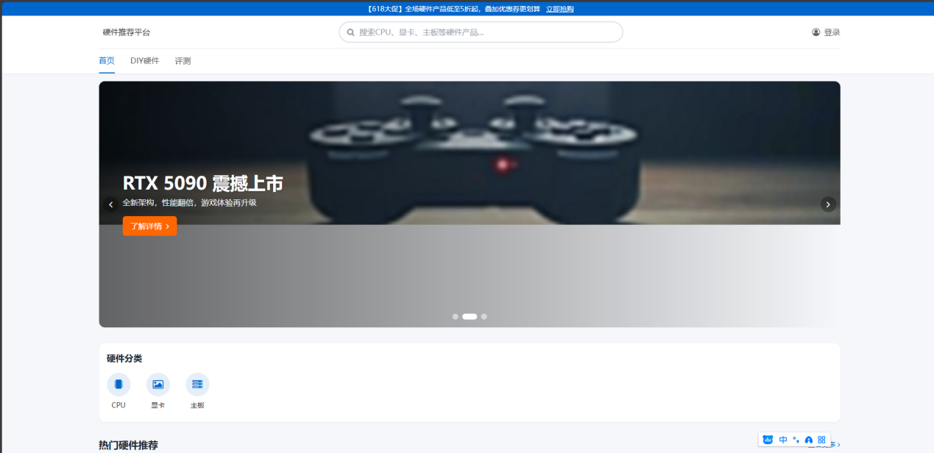
app:
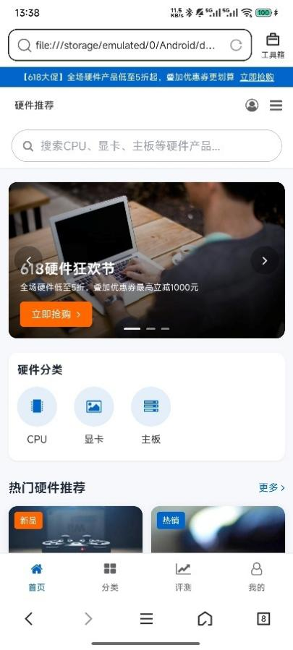

getUserInfo.html | 查看个人信息页面
changeUserInfo.html | 修改个人信息界面
changePassword.html | 修改密码
cancelUser.html | 注销账户页面
forgetPassword.html | 密码找回页面
web:
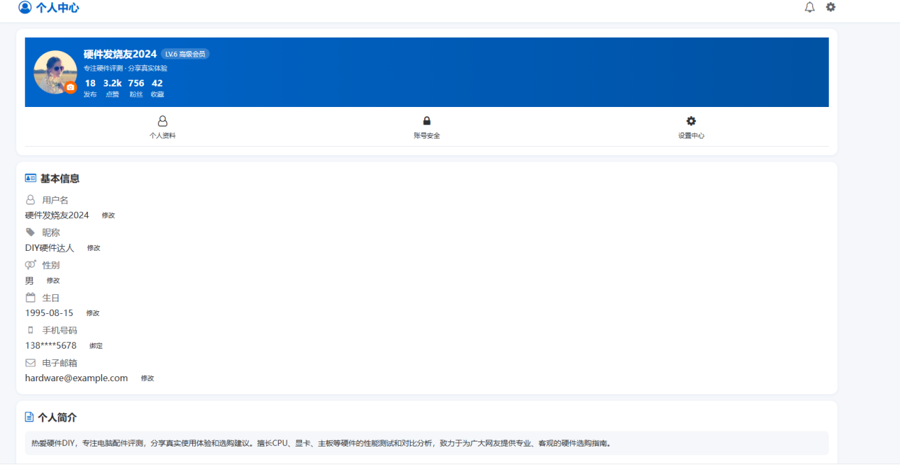
app:
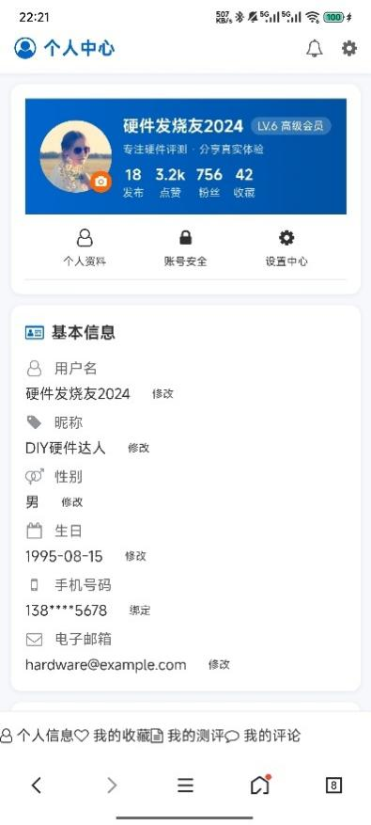

2、Administrator类
Index2.html | 管理员首页
manageUser.html | 管理用户账号页面
web: 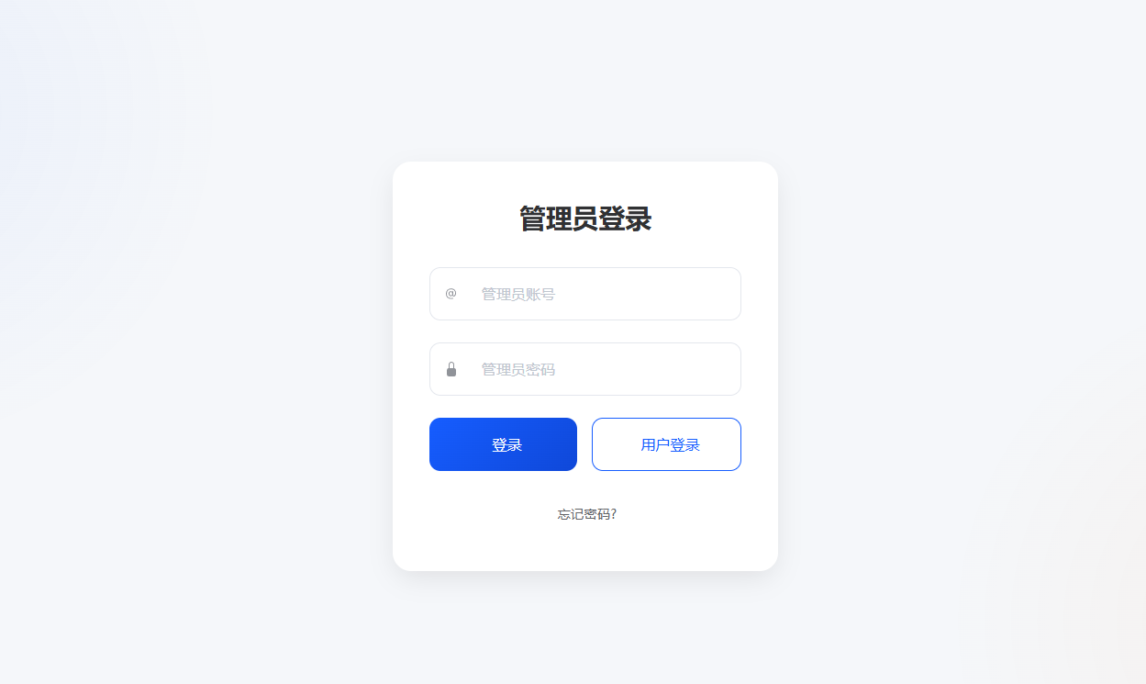
app:
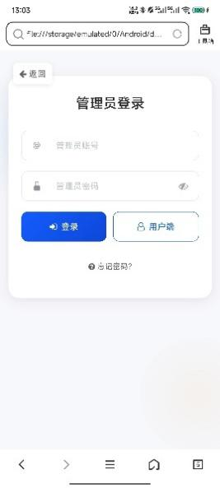
resultSearchUser.html | 查询用户结果页面
web:
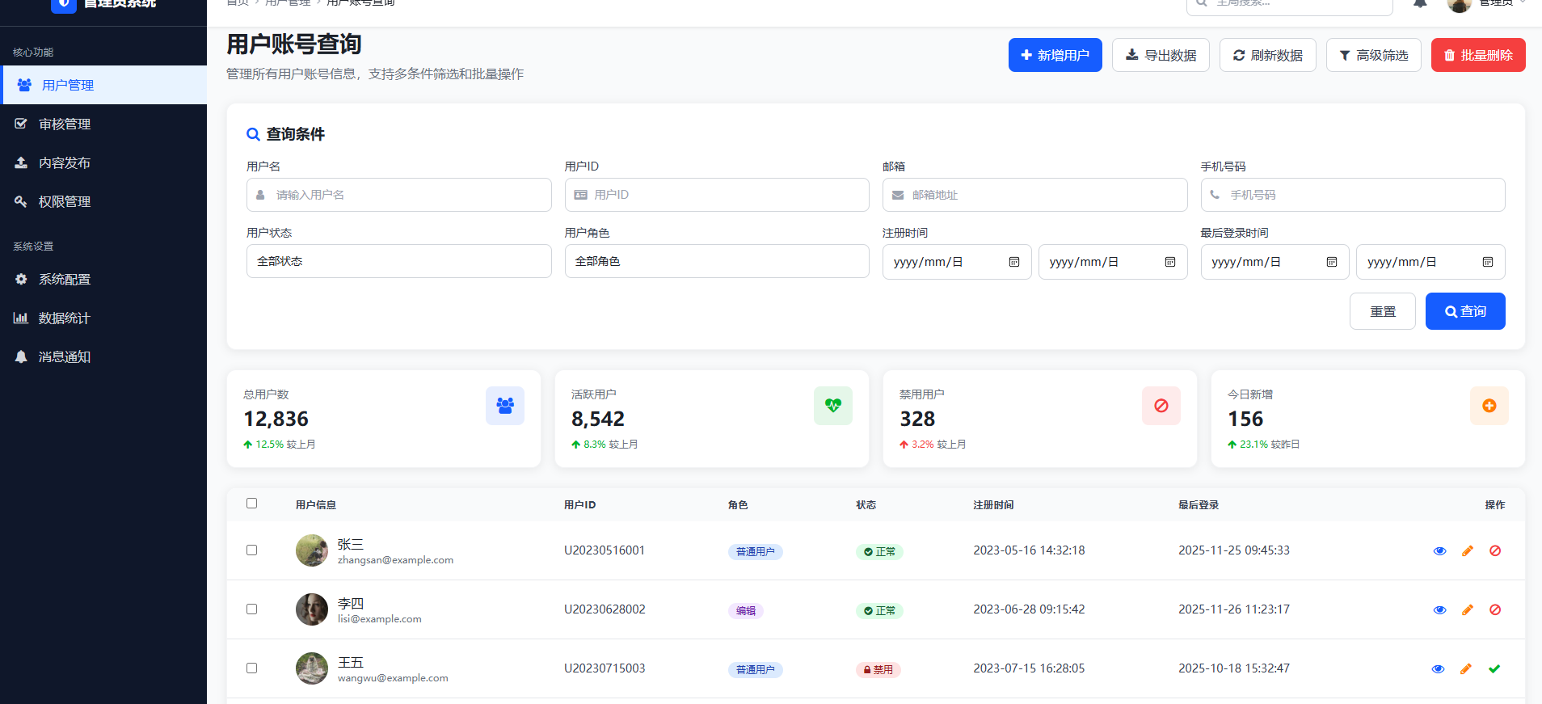
app:
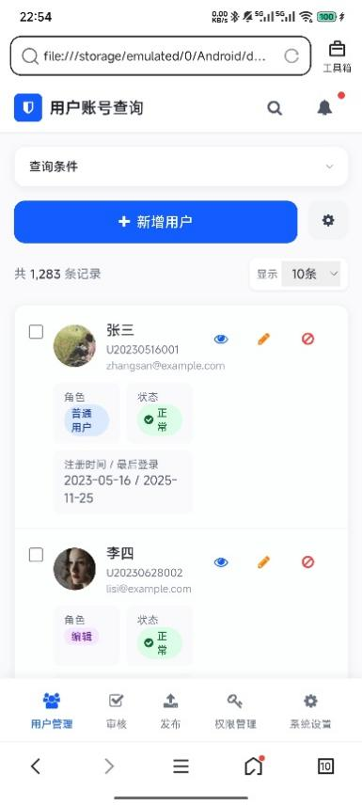

publishHardware.html | 发布硬件信息页面
editHardware.html | 编辑硬件信息页面
web:

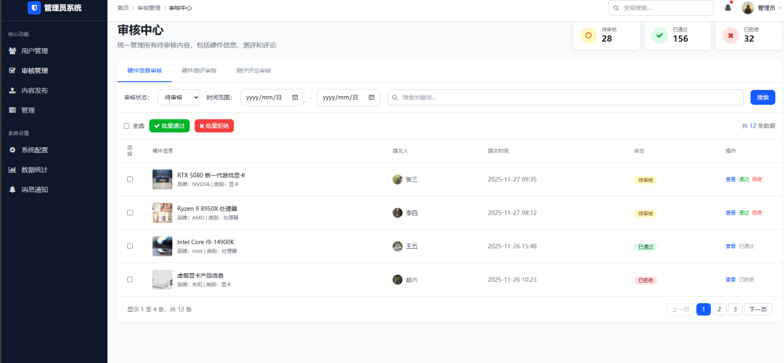
app: 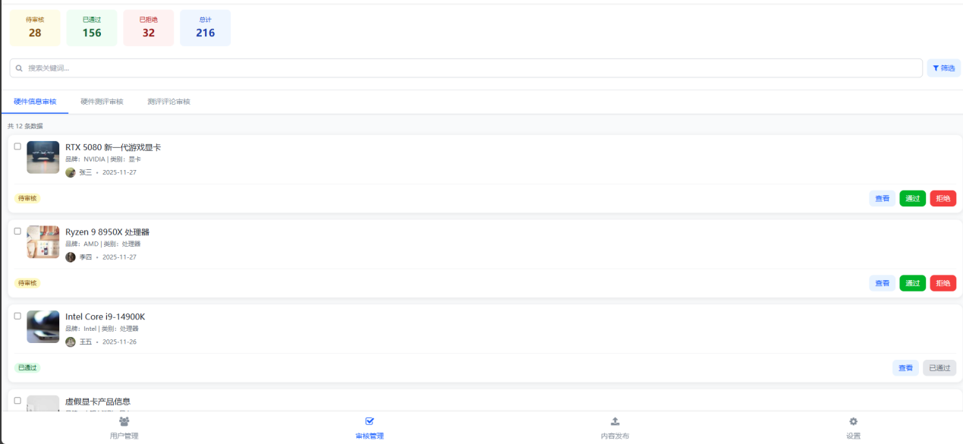
manageHardwareInf.html | 管理硬件信息页面
manageEvaluation.html | 管理硬件测评页面
searchComment.html | 查询测评评论页面
auditEvaluation.html | 审核硬件测评页面
auditHardwareInf.html | 审核硬件信息页面
auditComment.html | 审核测评评论页面
web:
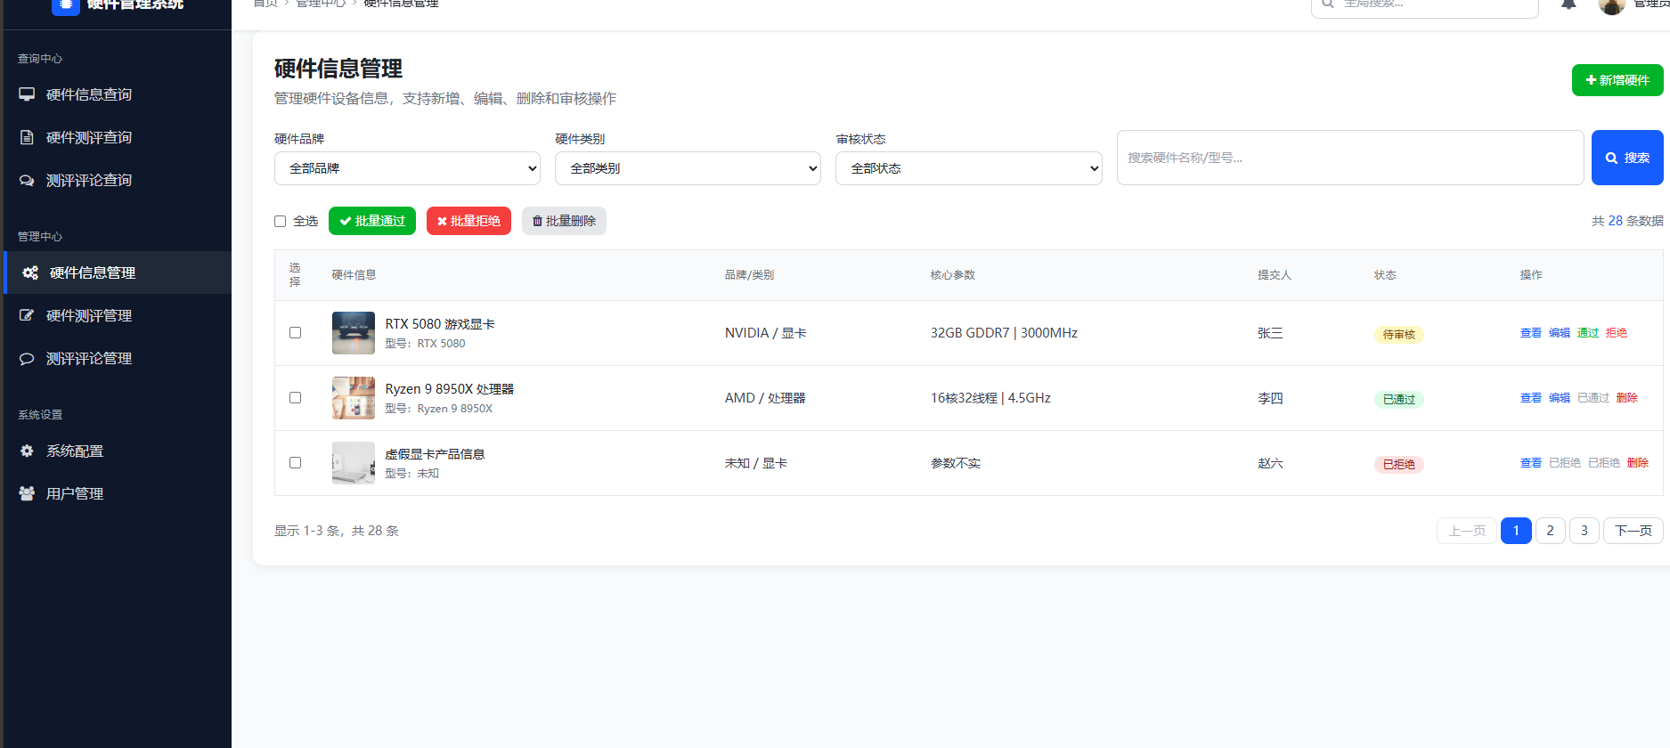
app:
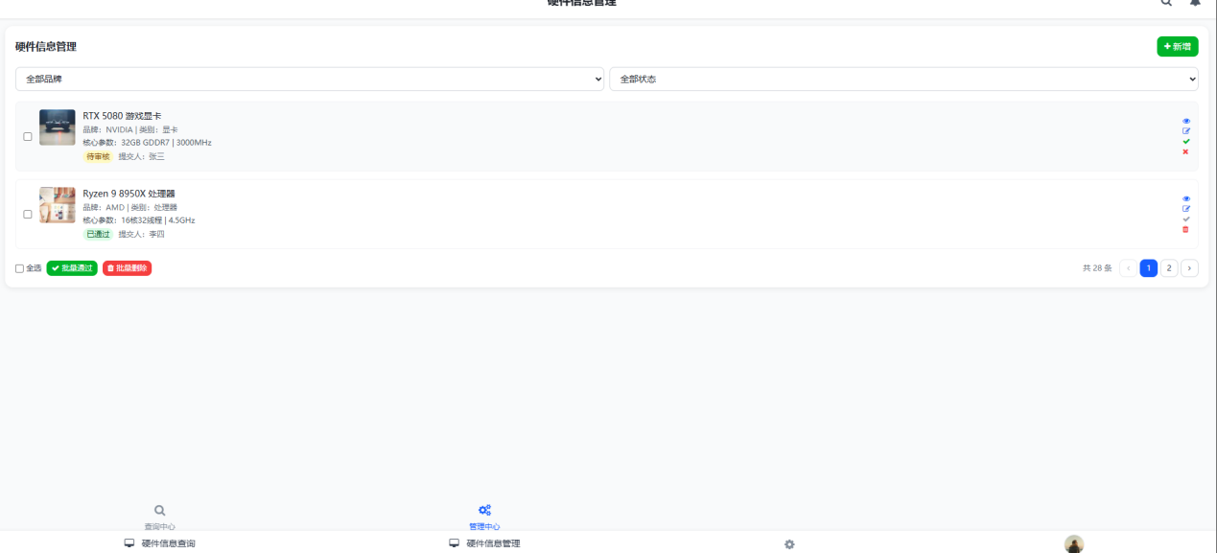

3、Hardware_Inf类
viewHardwareDetail.html | 硬件详情页面
searchHardware.html | 搜索硬件页面
searchEvaluation.html | 查询硬件测评页面
web: 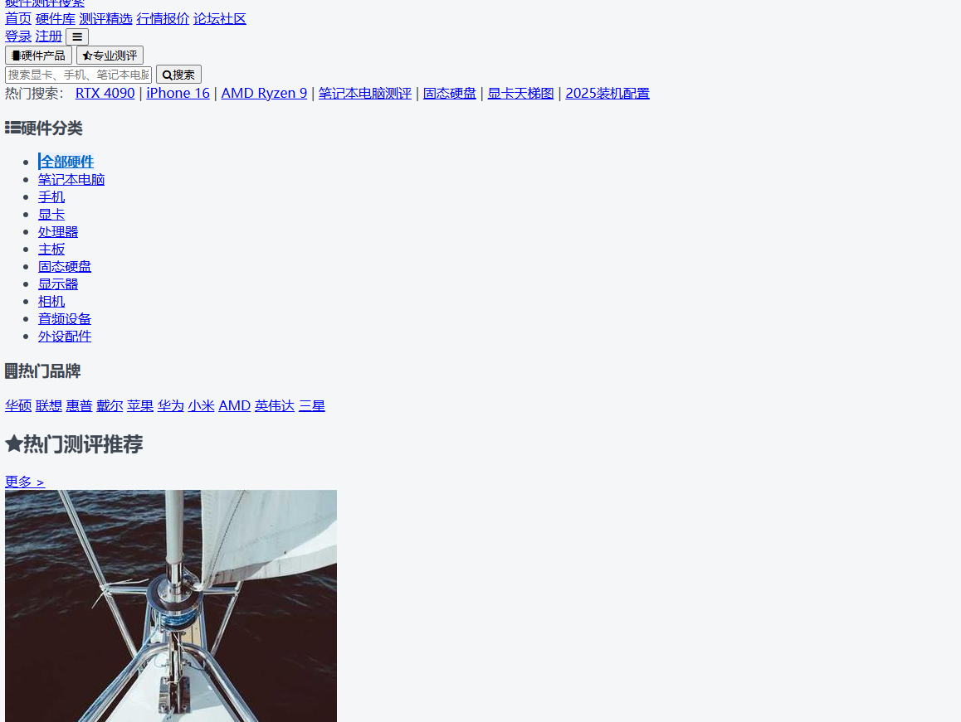
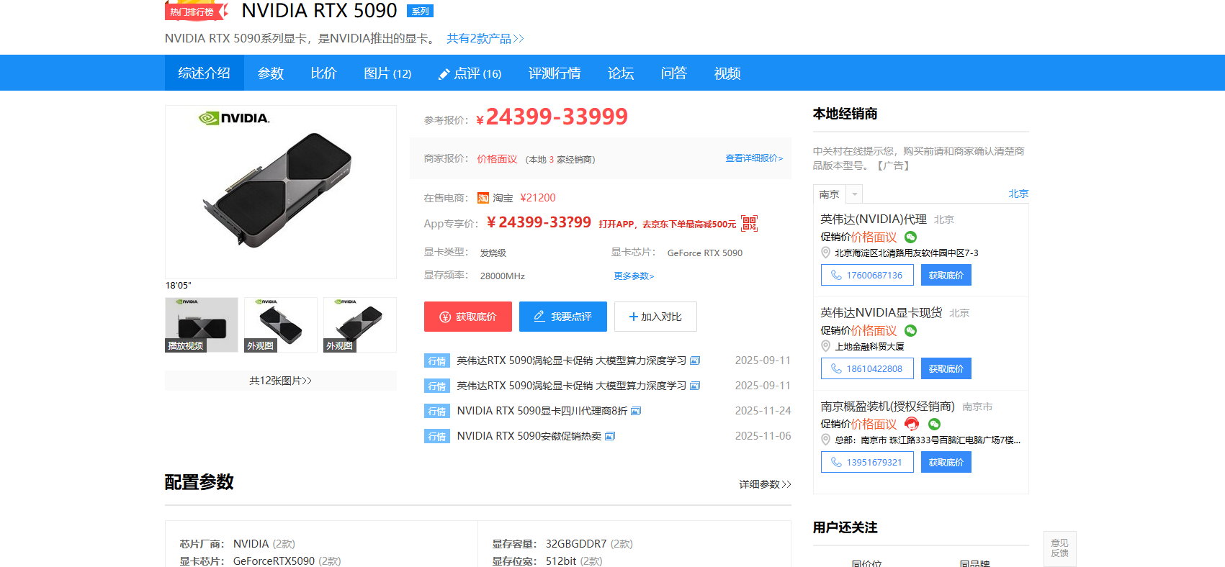
app:
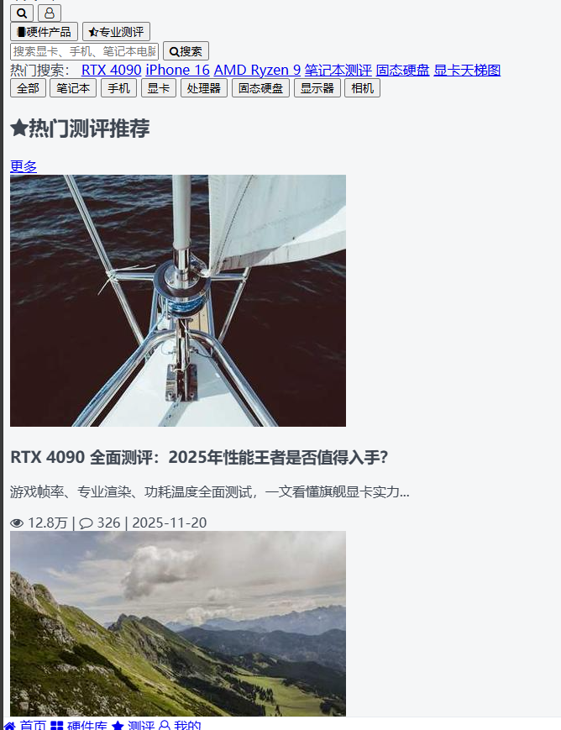
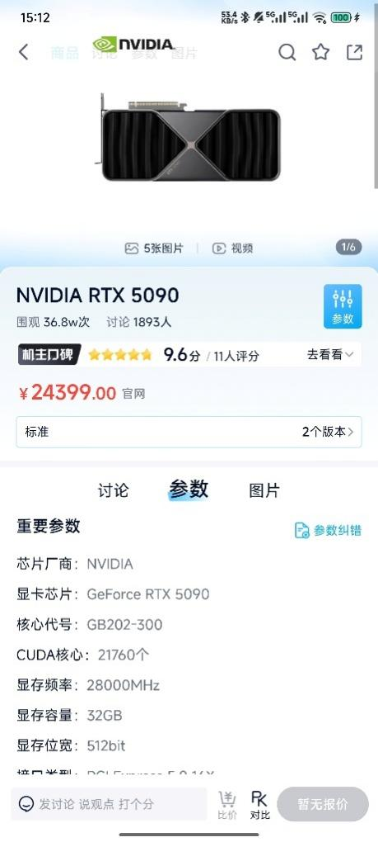

4、Evaluation类
addEvaluation.html | 发布硬件测评页面
editEvaluation.html | 编辑硬件测评页面

web: 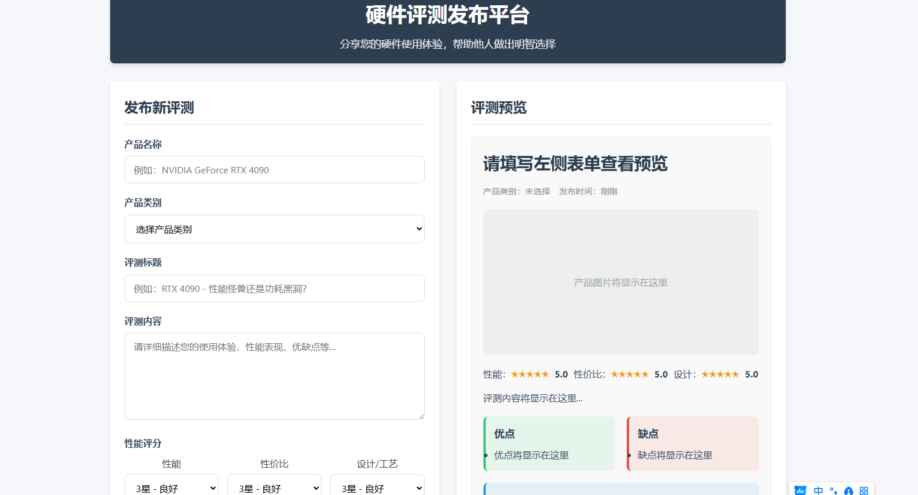
app:
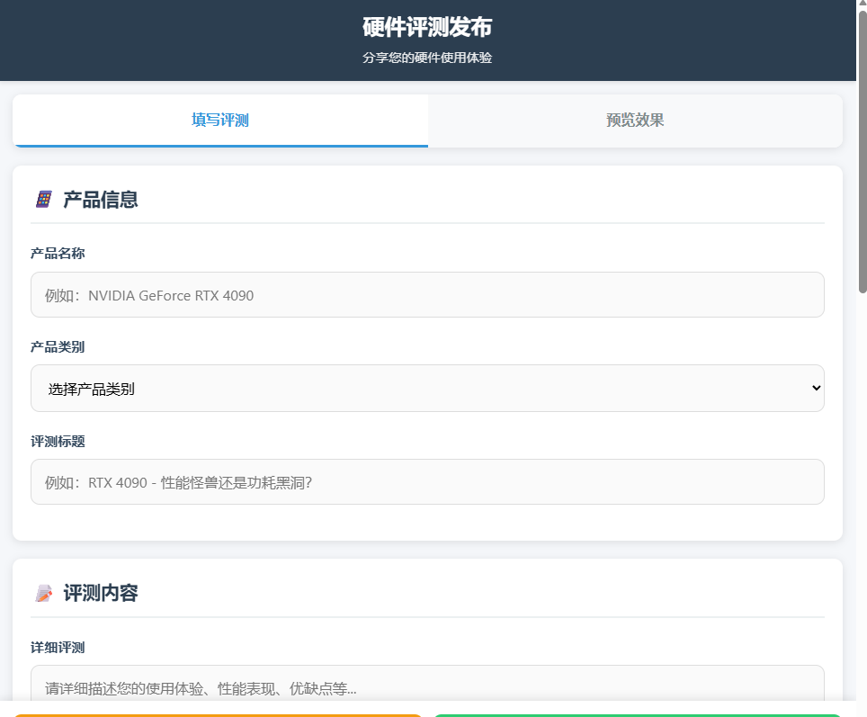

viewEvaluationDetail.html | 测评详情页面

web: 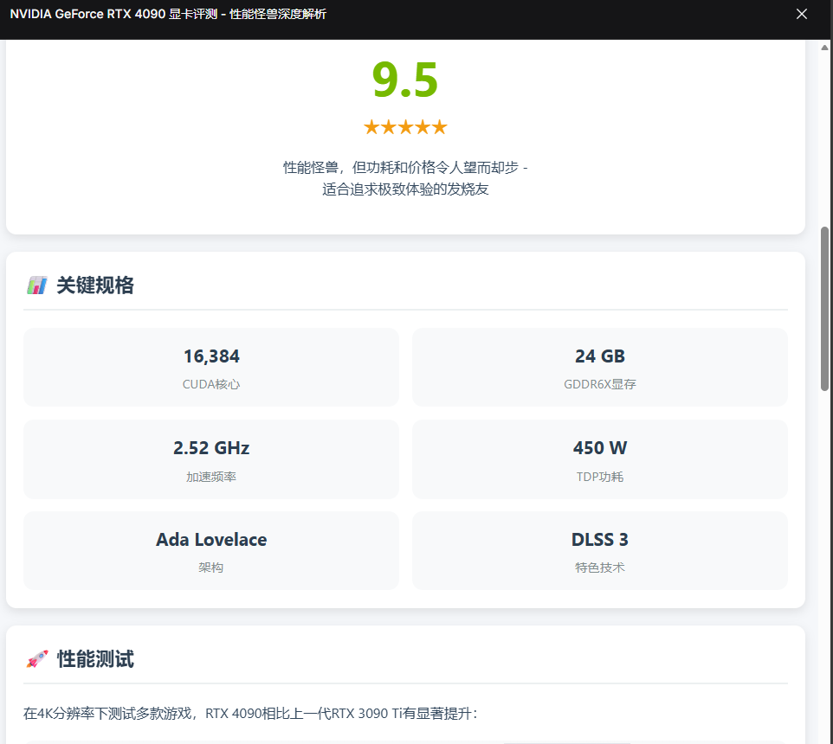
app:
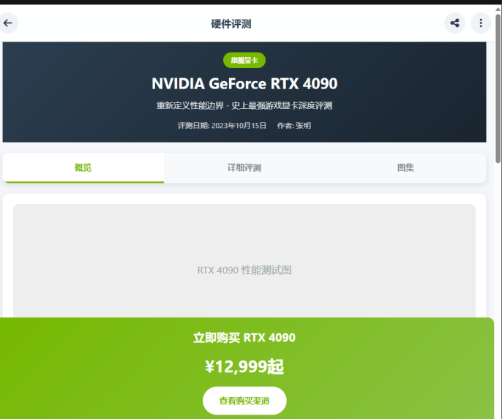

5、Collect类
manageCollect.html | 管理收藏页面
cancelCollect.html | 取消收藏页面
addCollect.html | 添加收藏页面（嵌入硬件详情页）
web: 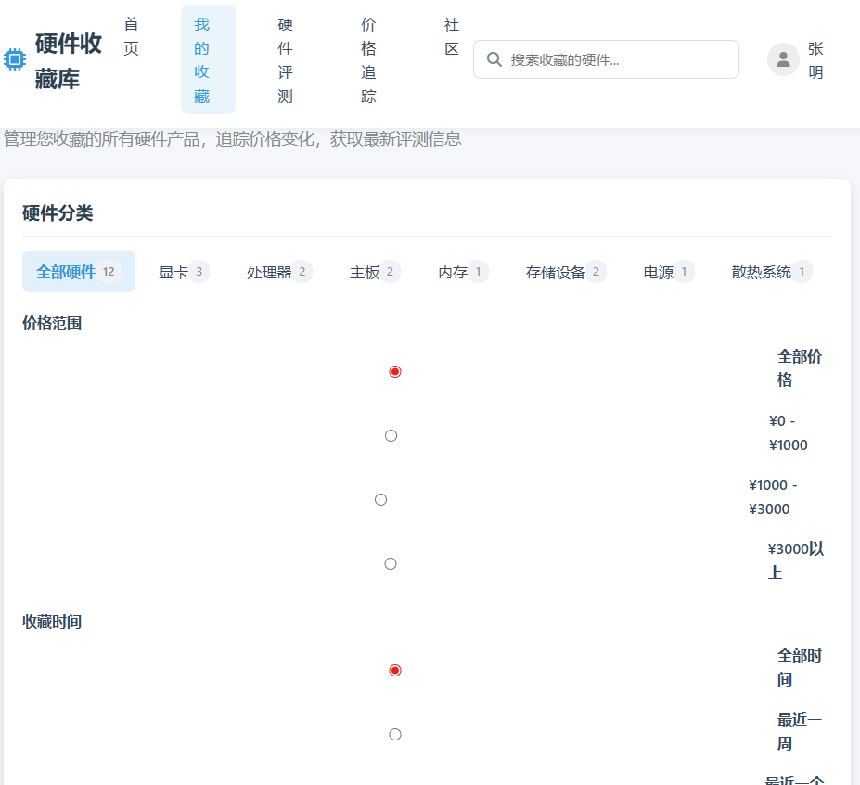
app:
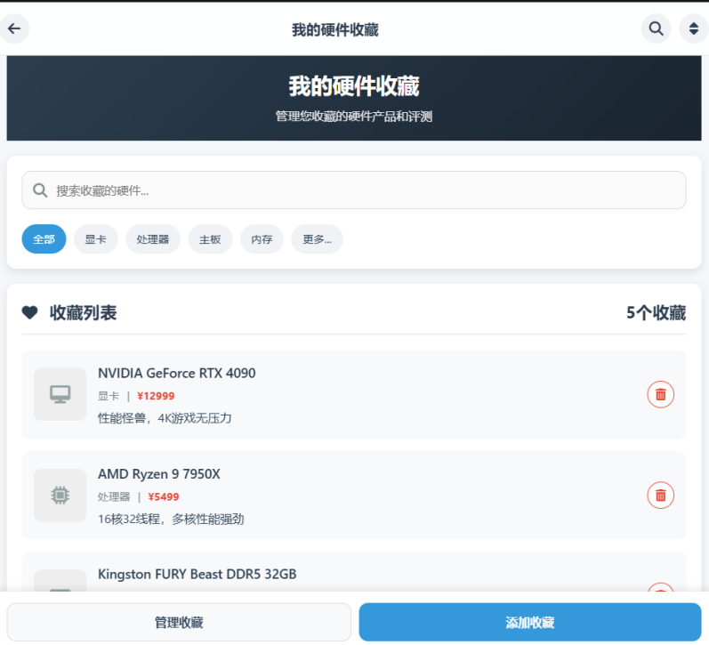

6、Comment类
addComment.html | 发布评论页面
editComment.html | 编辑评论页面
viewComment.html | 评论详情页面
web: 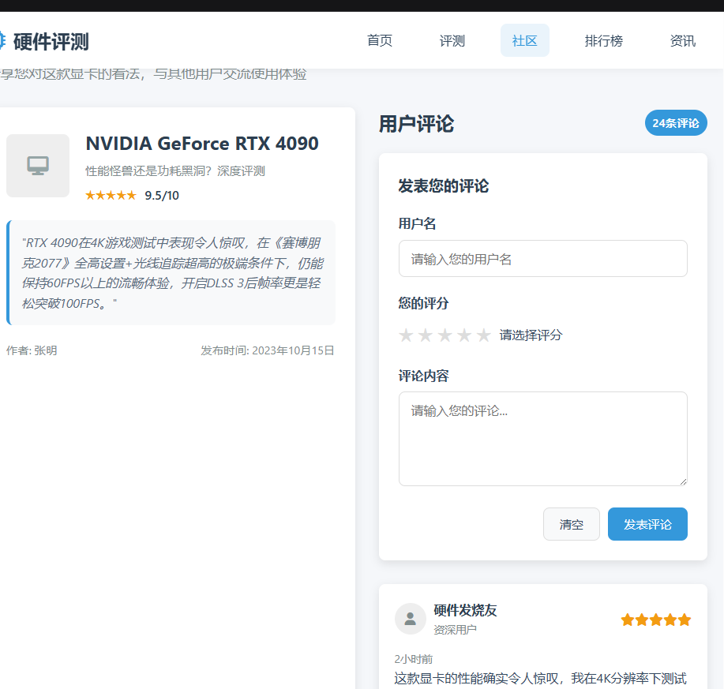
app:
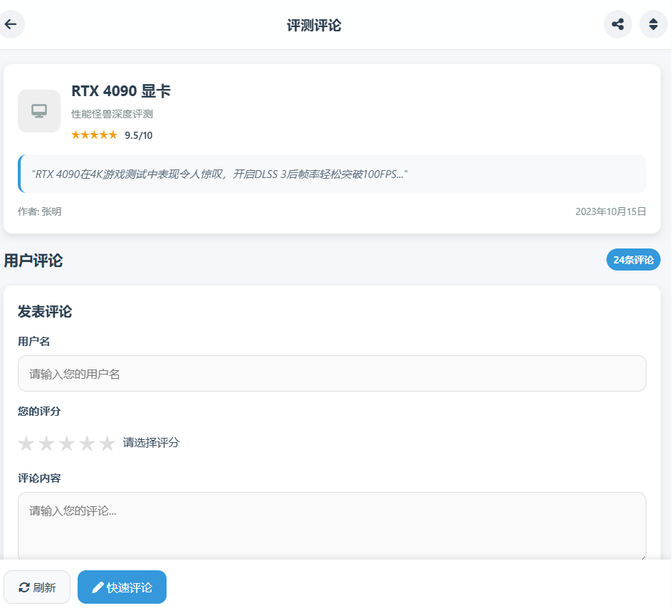

三、事务逻辑设计

1、OrdinaryUser类
登录处理
Procedure login
Begin
choose the method of login
If (choose the Account password login) then
get the usermailbox or phonenumber and userPassword from signin.html
find the usermailbox and password in the database
If (usermailbox not found ) or (usermailbox exist but inputPassWord != Password in database )then
display error hint
Else
goto index1.html
End if
Else if (choose the SMS verification code login) then
get the phonenumber and the verification from signin.html
find the phonenumber in the database and check the verification
If (phonenumber not find) or (the verification is not correct) then
display error hint
Else
goto index1.html
End if
End if
End login
注册处理
Procedure signup
Begin
get the new_user's info from signupOrdinaryUser.html
find the usermailbox or phonenumber in the database
If (the usermailbox or phonenumber existed in the database) then
show error hint
Else
send the verification to the user with SMS
get and check the verification from signupOrdinaryUser.html
If (the verification is not correct) then
show error hint and let the user try again
Else
add user's info to database
goto signin.html
End if
End if
End signup
修改个人信息处理
Procedure changeUserInfo
Begin
get the changed userinfo from changeUserInfo.html
find the user and the user's info in database
input the new info into database
goto getUserInfo.html
End changeUserInfo
修改密码处理
Procedure changepassword
Begin
get the originalpassword from changepassword.html
If the (inputpassword ==correct password in database) then
get two new_password which is inputted by the user twice
If (the two new_password is the same) then
find the user's info in the database
change the old_password into the new passwordgoto getUserInfo.html
Else
show error hint
End if
Else
show error hint
End if
End changepassword
忘记密码重置密码处理
Procedure forgetpassword
Begin
get the user's phonenumber from forgetpassword.html
find the user's phonenumber in the database
If (the user's phonenumber is existed) then
send the verification to the user with SMS
get and check the verification from forgetpassword.html
If (the verification is not correct) then
show error hint and let the user try again
Else
show the set_new_password page and let the user set the new password
get two new_password which is inputted by the user twice
If (the two new_password is the same) then
find the user's info in the database
change the old_password into the new-seted password
goto signin.html
Else
show error hint and let the user try again
End if
End if
Else
show error hint
End if
End forgetpassword
注销账号处理
Procedure cancelUser
Begin
get the cancelUser submit from getUserInfo.html
show cancelUser.html
get the result from cancelUser.html
If (the result is yes) then
find the user in database
cancel the user's account and set the account is non-existent in the database
goto signin.html
Else
return to getUserInfo.html
End if
End cancelUser

Administrator类
登录处理
Procedure login
Begin
choose the method of login
If (choose the Account password login) then
get the usermailbox or phonenumber and userPassword from signin.html
find the usermailbox and password in the database (filter administrator role)
If (usermailbox not found ) or (usermailbox exist but inputPassWord != Password in database )then
display error hint
Else
goto Index2.html
End if
Else if (choose the SMS verification code login) then
get the phonenumber and the verification from signin.html
find the phonenumber in the database (filter administrator role) and check the verification
If (phonenumber not find) or (the verification is not correct) then
display error hint
Else
goto Index2.html
End if
End if
End login
管理用户账号处理
Procedure manageUser
Begin
goto manageUser.html
choose the function of manageUser part
If (use the function of search_user) then
get the userinfo (username/phone/mailbox) inputted to search
find the user whose info matches the input in the database
If (the user exists in the database) then
goto resultSearchUser.html and show the search result
Else
show no search result hint
End if
Else if (use the function of change_user_info) then
select the designated user from the user list
show the user's concrete info
get the modified user info from the page
update the user's info in the database
goto manageUser.html and show modification success hint
Else if (use the function of delete_user_info) thenselect the designated user from the user list
get the administrator's password inputted
verify the input password with the administrator's password in the database
If (the password is correct) then
delete the designated user and all related info (collect, evaluation, comment) from the database
goto manageUser.html and show deletion success hint
Else
show password error hint
End if
End if
End manageUser
发布硬件信息处理
Procedure publishHardware
Begin
goto publishHardware.html
select hardware type (CPU/Motherboard/GraphicsCard)
fill in hardware info (parameters, price, stock, brand, model, etc.)
upload hardware images
click submit
save the hardware info to the database (status: pending audit)
show submission success hint
goto manageHardwareInf.html
End if
End publishHardware
编辑硬件信息处理
Procedure editHardware
Begin
goto manageHardwareInf.html
select the pending audit or published hardware to edit
goto editHardware.html and display the current hardware info
modify the hardware info (parameters, price, stock, etc.)
click submit
update the hardware info in the database (status: pending re-audit)
show edit submission success hint
goto manageHardwareInf.html
End editHardware
审核硬件信息处理
Procedure auditHardwareInf
Begin
goto auditHardwareInf.html
get the list of hardware info pending audit from the database
select the designated hardware to audit
view the hardware's detailed info (parameters, images, submitter, etc.)
choose audit result (pass/reject)
If (audit result is pass) then
update the hardware's status to published in the database
Else
fill in the rejection reason
update the hardware's status to rejected in the database
End if
submit the audit result
show audit completion hint
refresh auditHardwareInf.html to load the next pending audit hardware
End auditHardwareInf
管理硬件信息处理
Procedure manageHardwareInf
Begin
goto manageHardwareInf.html
select hardware status (pending audit/published/rejected) to filter
get the hardware list matching the status from the database
display the hardware list (including hardware name, model, status, publish time, etc.)
If (click audit) then
goto auditHardwareInf.html to audit the selected hardware
Else if (click edit) then
goto editHardware.html to edit the selected hardware
Else if (click offline) then
select the published hardware and confirm offline operation
update the hardware's status to offline in the database
show offline success hint
End if
End manageHardwareInf
审核硬件测评处理
Procedure auditEvaluation
Begin
goto auditEvaluation.htmlget the list of hardware evaluations pending audit from the database
select the designated evaluation to audit
view the evaluation's detailed content (performance data, experience, images, submitter, etc.)
choose audit result (pass/reject)
If (audit result is pass) then
update the evaluation's status to published in the database
Else
Fill in the rejection reason
update the evaluation's status to rejected in the database
End if
submit the audit result
show audit completion hint
refresh auditEvaluation.html to load the next pending audit evaluation
End auditEvaluation
管理硬件测评处理
Procedure manageEvaluation
Begin
goto manageEvaluation.html
select evaluation status (pending audit/published/rejected) to filter
get the evaluation list matching the status from the database
display the evaluation list (including title, submitter, publish time, status, etc.)
If (click audit) then
goto auditEvaluation.html to audit the selected evaluation
Else if (click delete) then
confirm deletion of the selected evaluation
delete the evaluation and related comments from the database
show deletion success hint
End if
End manageEvaluation
审核测评评论处理
Procedure auditComment
Begin
goto auditComment.htmlget the list of comments pending audit from the database
select the designated comment to audit
view the comment's content, corresponding evaluation, submitter, etc.
choose audit result (pass/reject)
If (audit result is pass) then
update the comment's status to published in the database
Else
fill in the rejection reason
update the comment's status to rejected in the database
End if
submit the audit result
show audit completion hint
refresh auditComment.html to load the next pending audit comment
End auditComment
查询测评评论处理
Procedure searchComment
Begin
goto searchComment.html
input search conditions (evaluation ID, submitter, comment content keyword, etc.)
send search request to database
get the comment list matching the conditions from the database
display the comment list (including content, submitter, publish time, status, etc.)
If (click delete) then
confirm deletion of the selected comment
delete the comment from the database
show deletion success hint
End if
End searchComment

Hardware_Inf类
硬件信息查询处理
Procedure searchHardware
Begin
goto searchHardware.html
input search conditions (brand, type, model, price range, parameters, etc.)
support multi-condition combination search
send search request to database
get the hardware info list matching the conditions from the database
sort the result by relevance/price/popularity (default: relevance)
display the hardware list on searchHardware.html
If (click hardware detail) then
goto viewHardwareDetail.html and display specific hardware info (parameters, price, stock, evaluation list, etc.)
End if
End searchHardware

4、Evaluation类
发布硬件测评处理
Procedure publishEvaluation
Begin
If (login() = true) then
goto publishEvaluation.html
fill in evaluation content (performance data, experience, advantages/disadvantages, etc.)
attach relevant images (optional)
click submit
send evaluation info to database (status: pending audit)
show submission success hint
goto myEvaluation.html
End if
End publishEvaluation
编辑硬件测评处理
Procedure editEvaluation
Begin
If (login() = true) then
goto myEvaluation.html (ordinary user) or manageEvaluation.html (administrator)
select the evaluation to edit (own evaluation for ordinary user, any evaluation for administrator)
goto editEvaluation.html and display current evaluation content
modify the evaluation content (performance data, experience, advantages/disadvantages, etc.)
update attached images (optional)
click submit
update the evaluation info in the database (status: pending re-audit)
show edit submission success hint
goto myEvaluation.html or manageEvaluation.html
End if
End editEvaluation
删除硬件测评处理
Procedure deleteEvaluation
Begin
If (login() = true) then
goto myEvaluation.html (ordinary user) or manageEvaluation.html (administrator)
select the evaluation to delete (own evaluation for ordinary user, any evaluation for administrator)
goto deleteEvaluation.html and confirm deletion
delete the evaluation and related comments from the database
show deletion success hint
goto myEvaluation.html or manageEvaluation.html
End if
End deleteEvaluation
查看硬件测评详情处理
Procedure viewEvaluationDetail
Begin
goto viewEvaluation.html
select the published evaluation from the list
goto viewEvaluationDetail.html
get the evaluation's detailed content from the database
display evaluation content (title, content, performance data, images, submitter, publish time)
get the published comments related to the evaluation from the database
display comments list on the page
support comment interaction (publish comment, reply comment if allowed)
End viewEvaluationDetail
测评查询处理
Procedure searchEvaluation
Begin
goto searchEvaluation.html
input search conditions (hardware model, submitter, evaluation keyword, publish time range, etc.)
send search request to database
get the evaluation list matching the conditions (filter published status for ordinary users)
display the evaluation list (title, hardware model, submitter, publish time, etc.)
If (click evaluation detail) then
goto viewEvaluationDetail.html
End if
End searchEvaluation

5、Collect类
收藏处理
Procedure Collect
Begin
If(login()=true) then
Find the Hardware_Inf
Enter the Hardware_Inf
If(!collect) then
Click the collect
else
Return;
End if
End Collect

取消收藏处理
Procedure CancelCollect
Begin
If(login()=true) then
Find the Hardware_Inf
Enter the Hardware_Inf
If(collect) then
Click the collect
else
Return;
End if
End CancelCollect

6、Comment类
发表评论
Procedure Comment
Begin
If(login()=true) then
Find the Evaluation
Enter the Evaluation
Enter the comment
End if
End Comment

编辑测评评论处理
Procedure editComment
Begin
If (login() = true) then
goto viewEvaluationDetail.html
find the comment published by the user
click edit button
goto editComment.html and display current comment content
modify the comment content
click submit
update the comment content in the database (status: pending re-audit)
show edit submission success hint
refresh viewEvaluationDetail.html
End if
End editComment
删除测评评论处理
Procedure deleteComment
Begin
If (login() = true) then
goto viewEvaluationDetail.html (own comment) or searchComment.html (administrator)
find the target comment
click delete button
goto deleteComment.html and confirm deletion
delete the comment from the database
show deletion success hint
refresh the current page
End if
End deleteComment
查看评论详情处理
Procedure viewCommentDetail
Begin
goto viewEvaluationDetail.html
select the comment from the comments list
display the comment's detailed info (content, submitter, publish time, reply content if any)
support reply operation (if allowed and logged in)
End viewCommentDetail

四、数据库设计

User类

OrdinaryUser类
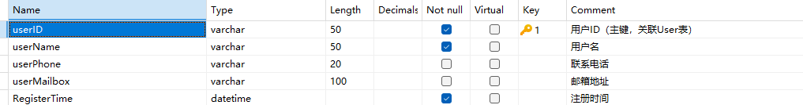

Administrator类
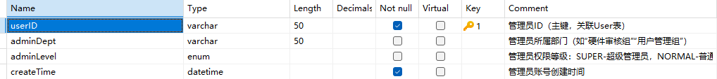

Hardware_Inf类（子类8选3）
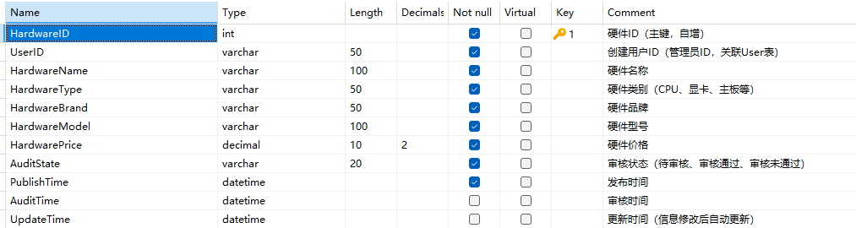

4.1、CPU_Inf类
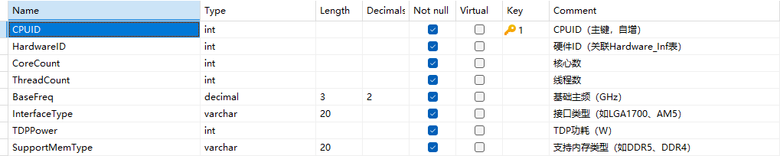
4.2、Motherboard_Inf类
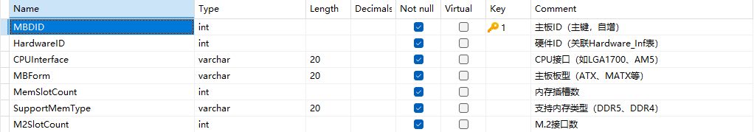

4.3、GraphicsCard_Inf类
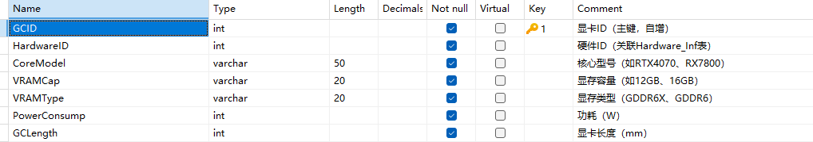

Evaluation类
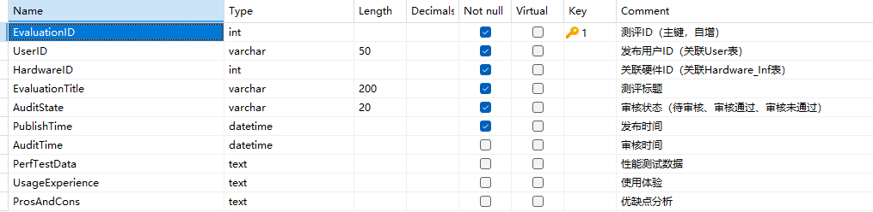

Collect类
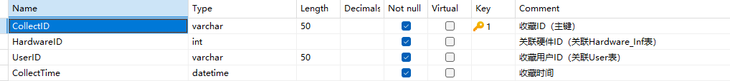

Comment类
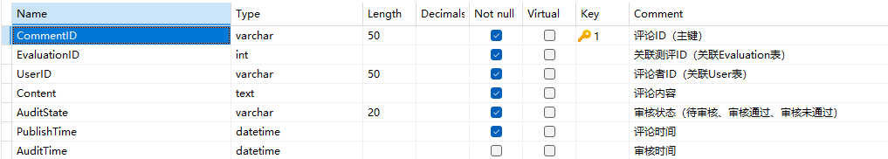

Media_Inf类
